**INTRODUCTION**

**1.1 PROJECT OVERVIEW**

The world in the 21st century is growing up in the technology in every field such as education, medicine, transport etc. The use of technology makes the world so faster and easier than the early world and it releases the world from manual usage in the every field.

In the early days, the manual usage causes many mistakes by the user and administrative. Using manual properties in the fields was not comfortable for the consumers because it was slower than technical usages, caused wastages of the consumers’ time and contained many formalities in usage.

“ZIMS” is this project of using technology in zoological parks for administration, maintenances, and entrance ticketing fields. Now also most of the zoological parks are using manual programs in their administration, maintenances and ticketing fields. This project was prepared for using computerized programs for the above fields. This was prepared for book visiting date in Zoological Park, because in that zoological park they used manual programs for administration, maintenance and ticketing field for long years. According to the basic needs of programs for this zoological park, this project was prepared to make the works easier.

According to the request of Zoological Park management for their basic needs of the computerized program for the above fields, this project has been designed. The goal of this project is to make the activities of the park easier and modernized.

* 1. **PROJECT SPECIFICATION**

This is a website in which we will get the services of several service providers. It will be a simple platform for users to access services for their huge needs. It provides the services to the users who are planning to visit a Zoological park. The system includes 2 modules. They are:

1. **Admin Module**: The admin can access the entire system functionalities.
2. **Users Module:** The Ordinary users can register and login to the system and book the visiting date in zoo and make payment details and can add their feedbacks.

The main features include:

* Registration and login
* Online booking
* View Zoo details
* Online Payment

**SYSTEM STUDY**

**2.1 INTRODUCTION**

System analysis is a process of gathering and interpreting facts, diagnosing problems and the information to recommend improvements on the system. It is a problem solving activity that requires intensive communication between the system users and system developers. System analysis or study is an important phase of any system development process. The system is studied to the minute’s detail and analyzed. The system analyst plays the role of the interrogator and dwells deep into the working of the present system. The system is viewed as a whole and the input to the system are identified. The outputs from the organizations are traced to the various processes. System analysis is concerned with becoming aware of the problem, identifying the relevant and decisional variables, analyzing and synthesizing the various factors and determining an optimal or at least a satisfactory solution or program of action.

In the existing system, all the records are not kept perfectly because all the work is done manually, so keeping up to date details of the zoo, timings of bookings, booking availability. Amount of the overall trips are kept in documents and the calculations done are manually which made lead to huge mistakes. Thus, the existing system is very time consuming and being manual work sometimes lead to a great loss as well.

Preliminary study is the process of gathering and interpreting facts, using the information for further studies on the system. Preliminary study is problem solving activity that requires intensive communication between the system users and system developers. It does various feasibility studies. In these studies, a rough figure of the system activities can be obtained, from which the decision about the strategies to be followed for effective system study and analysis can be taken.

**2.2 EXISTING SYSTEM**

The current system in the ZOOLOGICAL PARK has only the manual entry ticketing and the data’s both the visitors entries and zoo details are not saved in the secured database if leads to major drawback to handling the data with error.

## **2.3 PROPOSED SYSTEM**

The zoo can tackle the problem by upgrading to Computerized Systems. The system should be able to generate tickets based on the request of the user and must save the data back to the database on successfully generating of tickets. And Easy to keeping all the zoo details in a Proper way that can be maintained without any error data.

The Zoo information Management System is an independent product that automates all the tasks that are carried out in a Zoological park. It maintains all the details related to the various users involved in the booking of visiting date. The ZIMS keeps all the details of the booking including timing, price. It stores the day to day transactions which record the details of bookings. It handles the payments made by the different users during booking. It keeps information about the users. There is online booking facility and online payment.

The expected system should at least have two types of users with roles different from each other. The administrator has no limitation on handling data.The admin can have all right to the data, he can allow the new user into the system.

**2.4 PRODUCT FUNCTIONS**

The major functional modules are:

**Registration and login**

The Zoo Information Management System allows the users registration and login. The ordinary users can directly register their details and can login.

**Booking and Payment**

The main concern of zoo information management system is to book visiting day on zoo online. A registered user can only book also they can view and cancel bookings. The billing details are provided for the corresponding bookings and payment can be done online.

**Facilities**

Several facilities like user can view pictures of animals in zoo and can view zoo timing and ticket price.

**2.5 USER CHARACTERISTICS**

The ‘Zoo Information Management System’ has 2 users.

1. **Admin Module:** The admin can access the entire system functionalities. The Admin can login to the system, can view booking details, can remove or add registered users, add country. The Admin can view booking details. Also, the Admin can change the ticket price and booking

limit. And also view the feedbacks, admin can be approve or reject the feedback from the registered users.

**2. Users:** The Ordinary users can register and login to the system and book the visiting date and make payment details and can add their feedbacks. The payment can be done using card.

.

**SYSTEM ANALYSIS**

**3.1 FEASIBILITY STUDY**

Feasibility study is made to see if the project on completion will serve the purpose of the organization for the amount of work, effort and the time that spend on it. Feasibility study lets the developer foresee the future of the project and the usefulness. A feasibility study of a system proposal is according to its workability, which is the impact on the organization, ability to meet their user needs and effective use of resources. Thus, when a new application is proposed it normally goes through a feasibility study before it is approved for development.

The document provides the feasibility of the project that is being designed and lists various areas that were considered very carefully during the feasibility study of this project such as Technical, Economic and Operational feasibilities. The following are its features:

**3.1.1 Economical Feasibility**

Economic analysis is the most frequently used method for evaluating the effectiveness of a candidate system. More commonly known as cost benefit analysis, the procedure is to determine the benefits and savings that are expected from a candidate system and compare them with costs. If a benefit outweigh costs, then decision is made to design and implement the system. Otherwise, further justification or alteration in the proposed system will have to be made; if it is to have a chance of being approved. This ongoing effort improves in accuracy at each phase of the system lifecycle. The following are some of the important financial questions asked during preliminary investigation:

➢ The costs conduct a full system investigation.

➢ The cost of the hardware and software.

➢ The benefits in the form of reduced costs or fewer costly errors.

**3.1.2 Technical Feasibility**

Technical feasibility centers around the existing computer system (h/w, s/w) and to what extend it can support the proposed addition. For example if the current computer is operating at 80% capacity and arbitrary ceiling then running another application could overload the system or require additional hardware. This involves financial consideration to accommodate technical enhancement. If the budget is serious constraint then the project is judged not feasible. The technical feasibility issues usually raised during the feasibility stage of investigation includes:

➢ The hardware required is the minimum hardware for running the web browsers.

➢ The web application can be expanded easily to include more functionality.

➢ This web application can run in any type of Operating system which has JavaScript enabled web browsers.

**3.1.3 Behavioral Feasibility**

This includes the following questions:

• Is there sufficient support for the users?

• Will the proposed system cause harm?

The project would be beneficial because it satisfies the objectives when developed and installed. All behavioral aspects are considered carefully and conclude that the project is behaviourally feasible.

**3.2 SYSTEM SPECIFICATION**

**3.2.1 Hardware Specification**

Processor : Pentium IV/AMD Dual core and above

RAM : 4 GB

Hard disk : 500 GB

**3.2.2 Software Specification**

Front End : PHP

Backend : MYSQL

Client on PC : Windows 7 and above.

Technologies used : JS, HTML5, AJAX, J Query ,CSS

**3.3 SOFTWARE DESCRIPTION**

### 3.3.1 PHP

PHP is a server side scripting language designed for web development but also used as a general purpose programming language. PHP is now installed on more than 244 million websites and 2.1 million web servers. Originally created by Rasmus Ledorf in 1995, the reference implementation of PHP is now produced by the PHP group. While PHP originally stood for personal Home page, it now stands for PHP: Hypertext Preprocessor, a recursive acronym .PHP code is interpreted by a web server with a PHP processor module which generates the resulting web page. PHP commands can be embedded directly into a HTML source document rather than calling an external file to process data. It has also evolved to include a command-line interface capability and can be used in standalone incompatible with the GNU General Public License (GPL) due to restrictions on the usage of the term PHP.PHP can be deployed on most web servers and also as a standalone shell on almost every operating system and platform, free of charge.

**3.3.2 MySQL**

MySQL, the most popular Open Source SQL database management system, is developed, distributed, and supported by Oracle Corporation.

**• MySQL is a database management system**.

A database is a structured collection of data. It may be anything from a simple shopping list to a picture gallery or the vast amounts of information in a corporate network. To add, access, and process data stored in a computer database, you need a database management system such as MySQL Server. Since computers are very good at handling large amounts of data, database management systems play a central role in computing, as standalone utilities, or as parts of other applications.

• **MySQL databases are relational.**

A relational database stores data in separate tables rather than putting all the data in one big storeroom. The database structures are organized into physical files optimized for speed. The logical model, with objects such as databases, tables, views, rows, and columns, offers a flexible programming environment. You set up rules governing the relationships between different data fields, such as one-to-one, one-to-many, unique, required or optional, and “pointers” between

different tables. The database enforces these rules, so that with a well-designed database, your application never sees inconsistent, duplicate, orphan, out-of-date, or missing data.

The SQL part of “MySQL” stands for “Structured Query Language”. SQL is the most common standardized language used to access databases. We use the phrase “the SQL standard” to mean the current version of the SQL Standard at any time.

• **MySQL software is Open Source**.

Open Source means that it is possible for anyone to use and modify the software. Anybody can download the MySQL software from the Internet and use it without paying anything. If you wish, you may study the source code and change it to suit your needs. The MySQL software uses the GPL (GNU General Public License), to define what you may and may not do with the software in different situations.

• **The MySQL Database Server is very fast, reliable, scalable, and easy to use**

MySQL Server can run comfortably on a desktop or laptop, alongside your other applications, web servers, and so on, requiring little or no attention. If you dedicate an entire machine to MySQL, you can adjust the settings to take advantage of all the memory, CPU power, and I/O capacity available. MySQL can also scale up to clusters of machines, networked together. MySQL Server was originally developed to handle large databases much faster than existing solutions and has been successfully used in highly demanding production environments for several years. Although under constant development, MySQL Server today offers a rich and useful set of functions. Its connectivity, speed, and security make MySQL Server highly suited for accessing databases on the Internet.

• **MySQL Server works in client/server or embedded systems**.

The MySQL Database Software is a client/server system that consists of a multi-threaded SQL server that supports different backend, several different client programs and libraries, administrative tools, and a wide range of application programming interfaces (APIs).

• **A large amount of contributed MySQL software is available**.

MySQL Server has a practical set of features developed in close cooperation with our users. It is very likely that your favorite application or language supports the MySQL Database Server.

**SYSTEM DESIGN**

**4.1 ARCHITECTURAL DESIGN**

This section describes the components of the Zoo Information Management System. The admin and user will access the Zoo Information Management System through internet using their Laptop, Smart Phone, Tablet or Desktop Computer. The System’s application program process the user’s request and provides the required services by taking data from the system database.

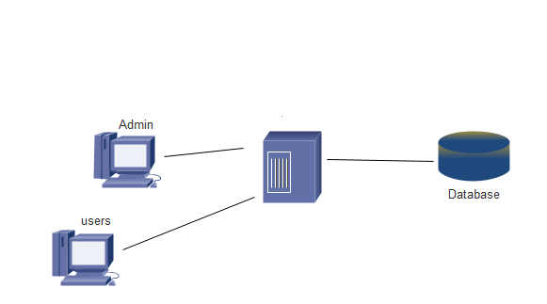

**Figure 1 Architectural Design**

**4.2 MODULE DESIGN**

**Admin Module**

The admin can access the entire system functionalities. The Admin can login to the system, can view booking details, can remove or add registered users, add country. The Admin can view booking details. Also, the Admin can change the ticket price and booking limit. And also view the feedbacks, admin can be approve or reject the feedback from the registered users.

**User Module**

After registration, user can book a visiting date on zoo, book his service if it is available. The payment can be done using card. User can give the feedbacks to the system.

**4.3 DATA FLOW DIAGRAM**

Data Flow Diagram (DFD) describes the flow of data and the processes that change data throughout a system. It’s a structured analysis and design tool that can be used for flowcharting

in place of or in association with information oriented and process oriented system flowcharts. When analysts prepare the Data Flow Diagram, they specify the user needs at a level of detail that virtually determines the information flow into and out of the system and the required data resources. This network is constructed by using a set of symbols that do not imply physical implementations. The Data Flow Diagram reviews the current physical system, prepares input and output specification, specifies the implementation plan etc.

Throughout the project, the context flow diagrams, data flow diagrams and flow charts have been extensively used to achieve the successful design of the system.

A data flow diagram also known as “bubble chart” which has the purpose of clarifying system requirements and identifying major transformations that will become programs in system design. It functionally decomposes the requirement specification down to the lowest level. DFD depicts the information flow, the transformation flow and the transformations that are applied as data move from input to output.

Main symbols used in the data flow diagram are:

1. Circle represents a process that transforms incoming data flows in to outgoing data flows.

2. A square defines a source and destination of system data.

3. Arrow identifies data in motion.

* 1. An open rectangle defines a data store, data at rest or temporary repository of data.

***DATA FLOW DIAGRAMS OF ZOO INFORMATION MANAGEMENT SYSYTEM***

***CONTEXT DIAGRAM FOR ZOO INFORMATION MANAGEMENT SYSYTEM***

**Figure 2: Context Diagram**

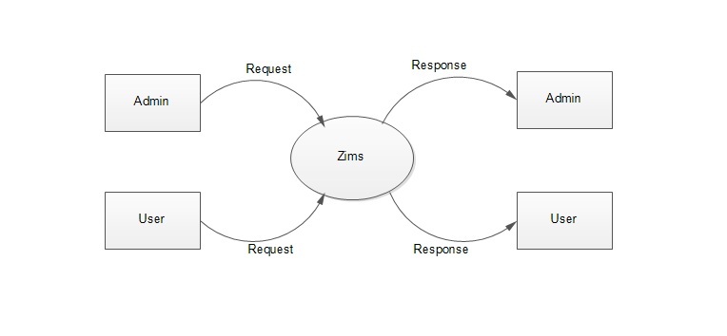

***LEVEL-1 DFD FOR ADMIN***

**Figure 3: Level 1 DFD for Admin**

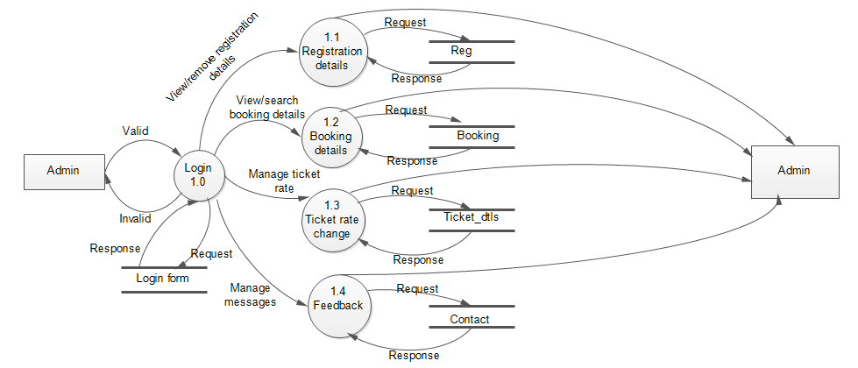

***LEVEL 2 DFD FOR ADMIN***

**Figure 4: Level 2 DFD for Admin**

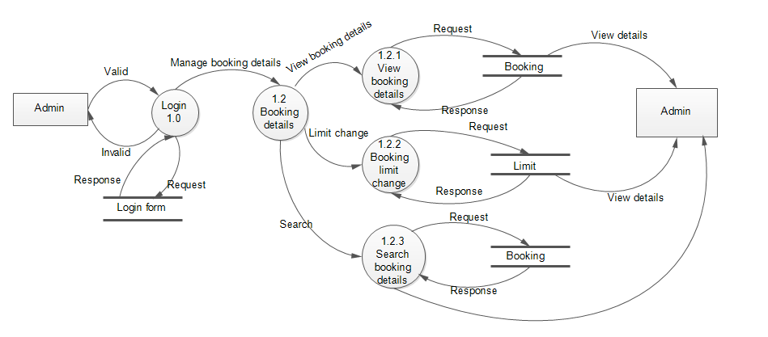

***LEVEL 2 DFD FOR ADMIN***

**Figure 5: Level 2 DFD for Admin**

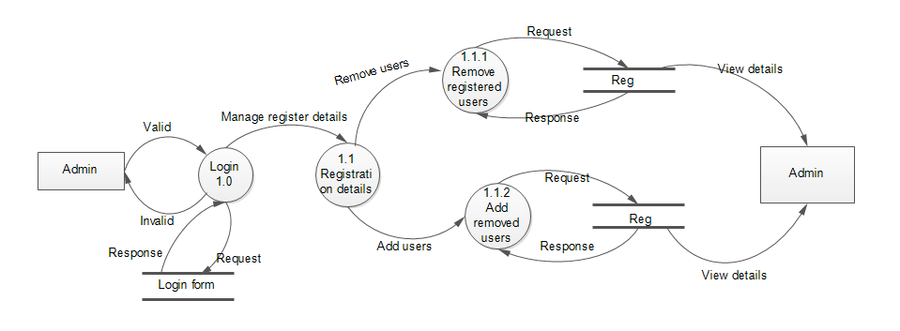

***LEVEL 1 DFD FOR USER***

**Figure 6: Level 1 DFD for User**

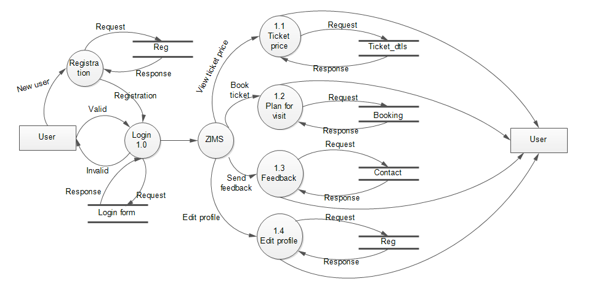

# 

***LEVEL 2 DFD FOR USER***

**Figure 7: Level 2 DFD for User**

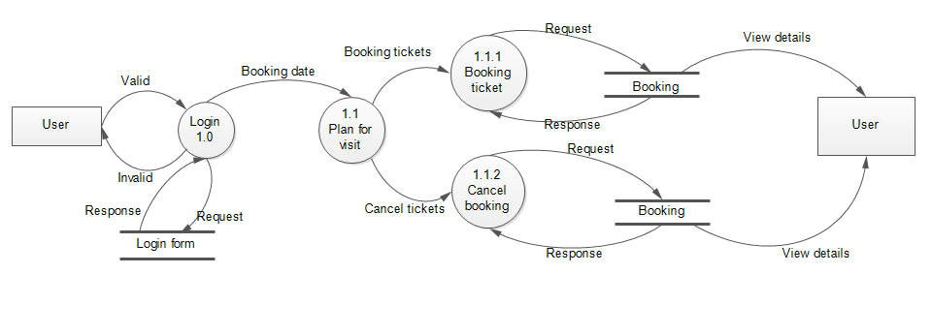

**4.4 UML DIAGRAM**

### *4.4.1 USE CASE DIAGRAM*

**Figure 8: Use case diagram for Admin**

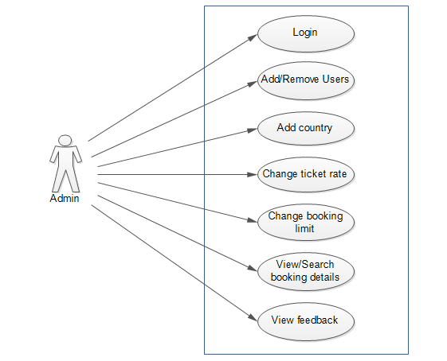

**Figure 9: Use case diagram for user**

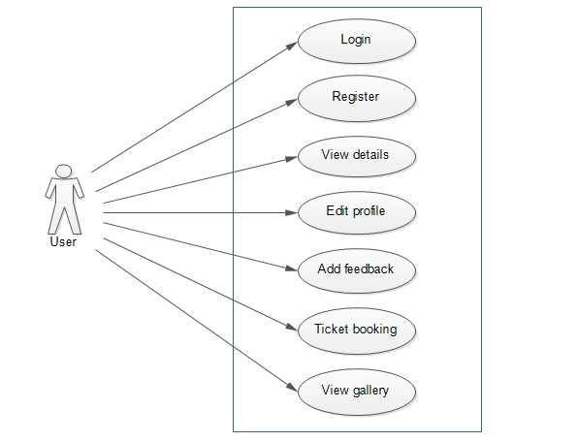

**Figure 10: Use case diagram for Zoo Information Managemnt System**

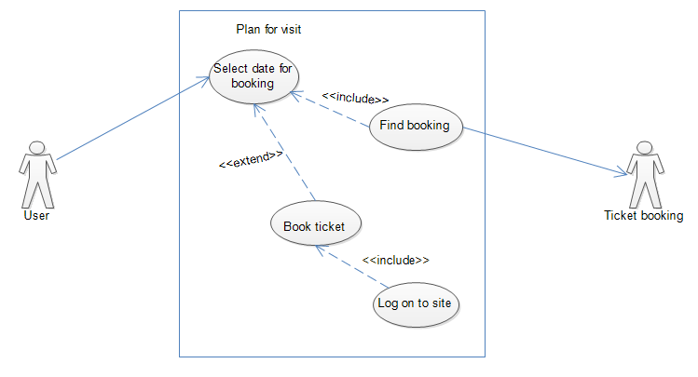

4.5 USER INTERFACE DESIGN

**Figure 11: Registration page**

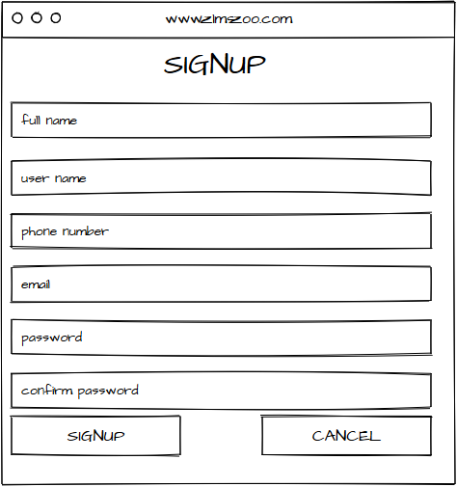

### 

**Figure 12: User page**

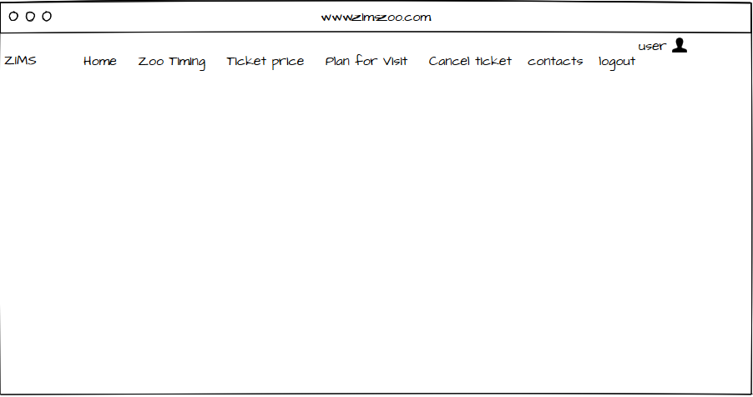

**Figure 13: Admin page**

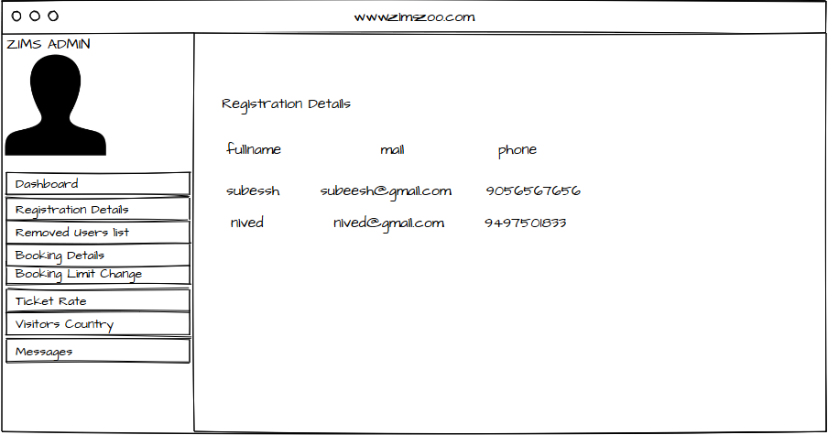

4.6 SCREENSHOTS

**Figure 14: Index page**

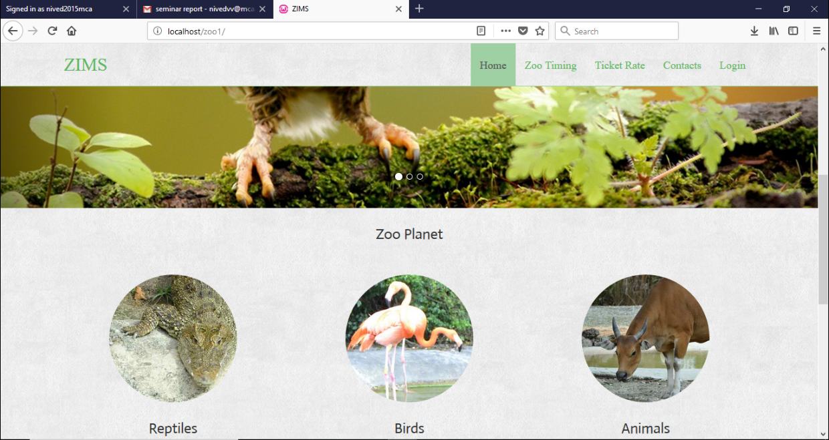

**Figure 15: Login**

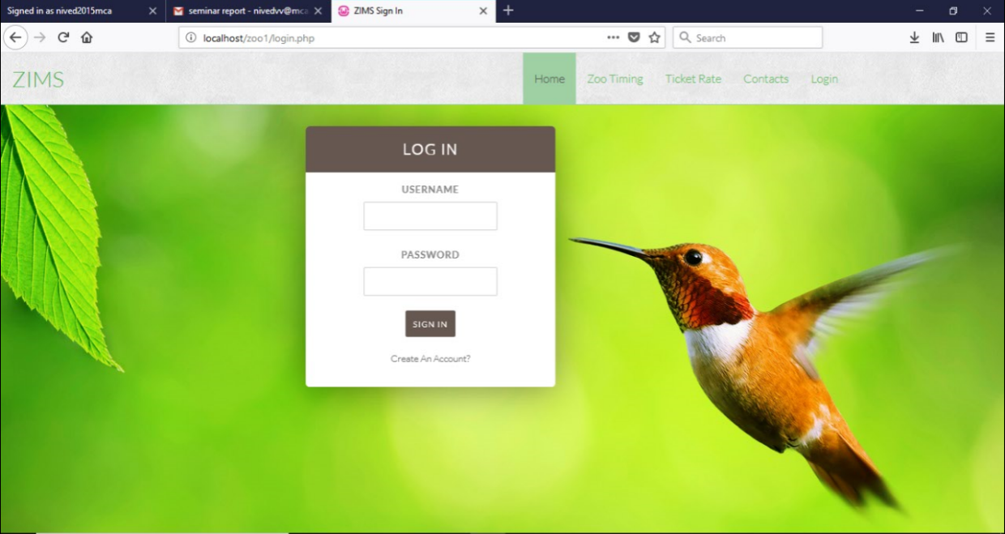

**Figure 16: User Registration**

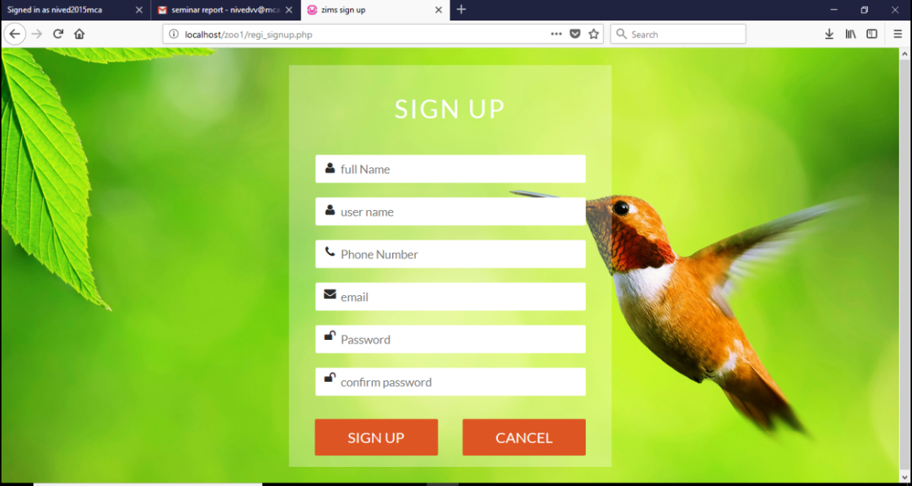

**Figure 17: Change booking limit**

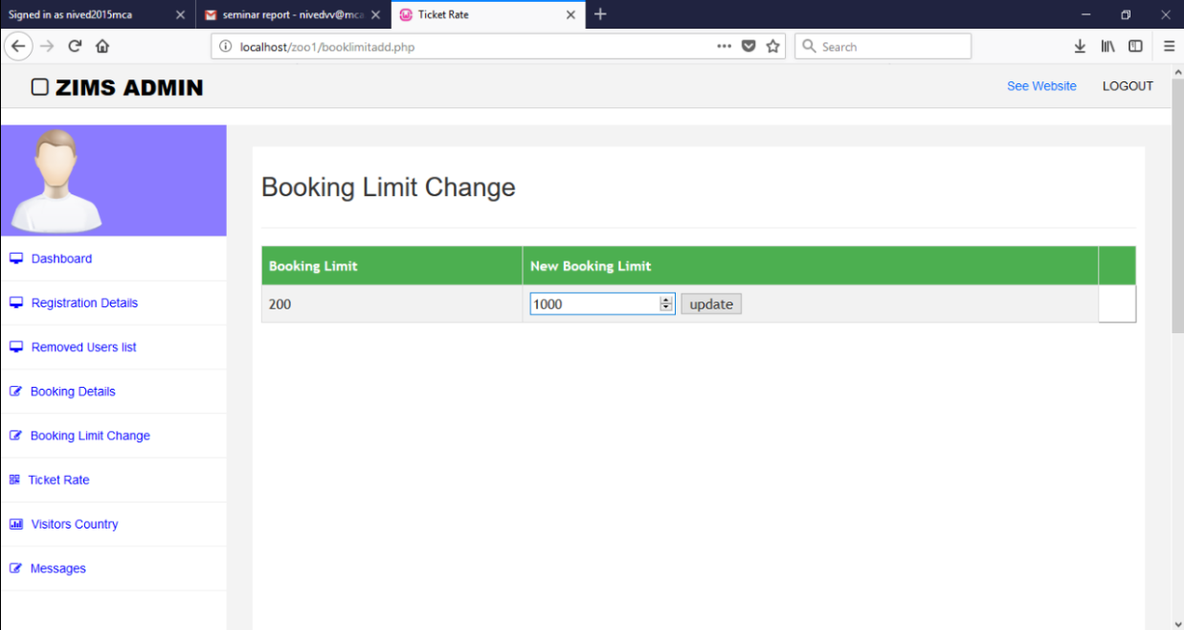

**Figure 18: Change ticket rate**

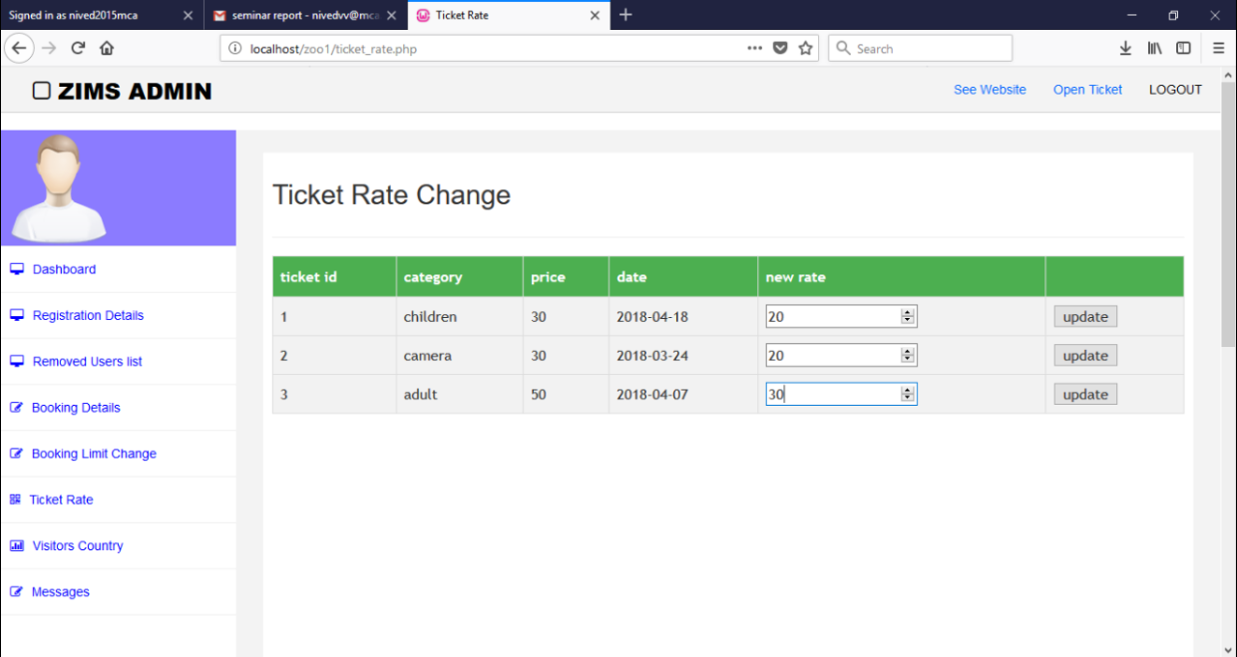

**Figure 19: View registration details**

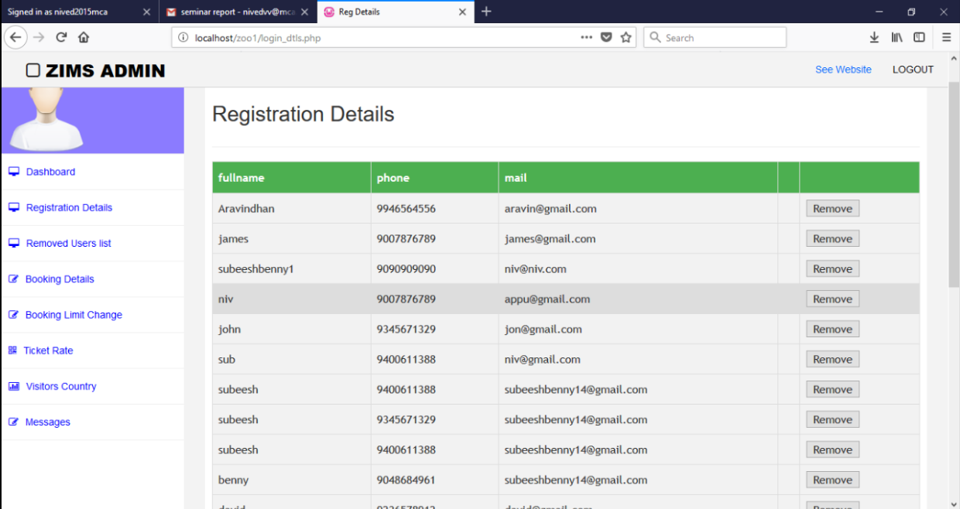

**Figure 20: View booking details**

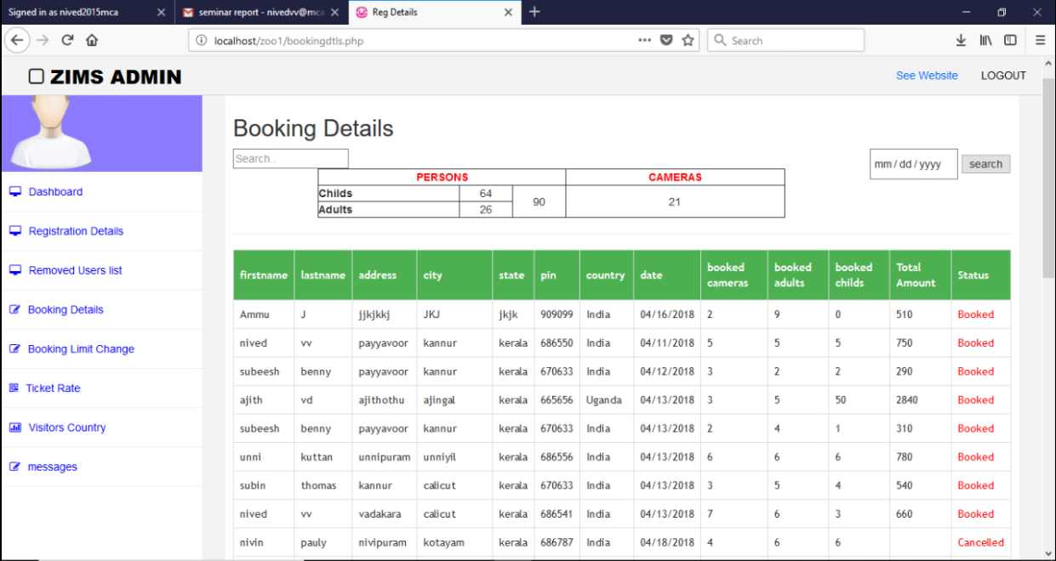

**Figure 21: User home page**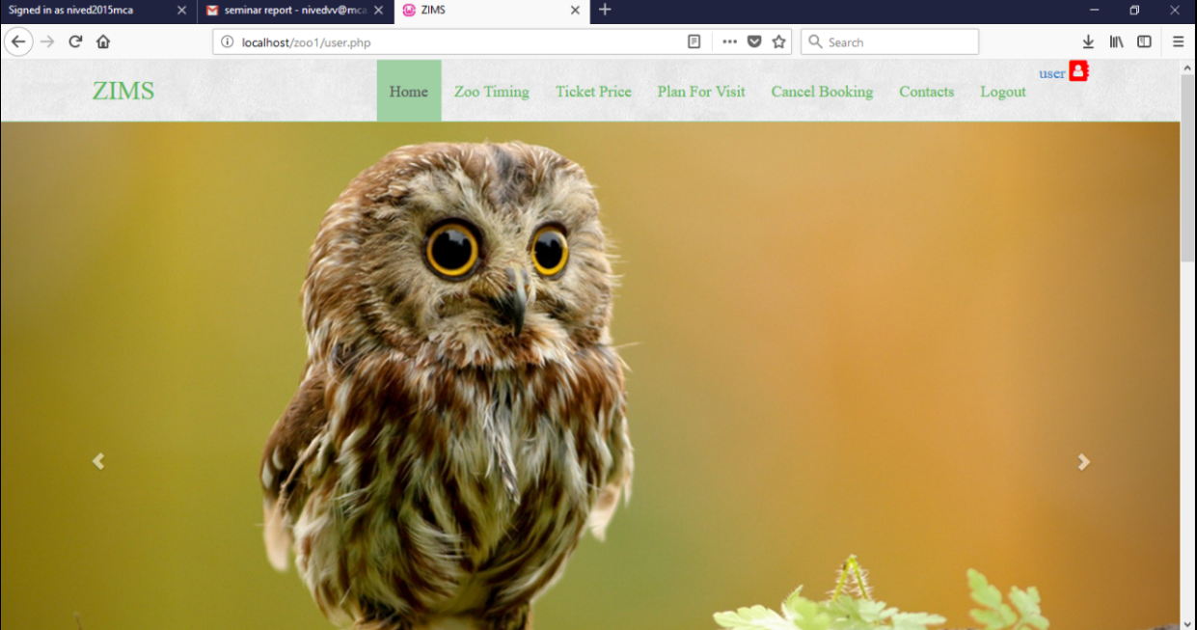

**Figure 22: Plan for visit**

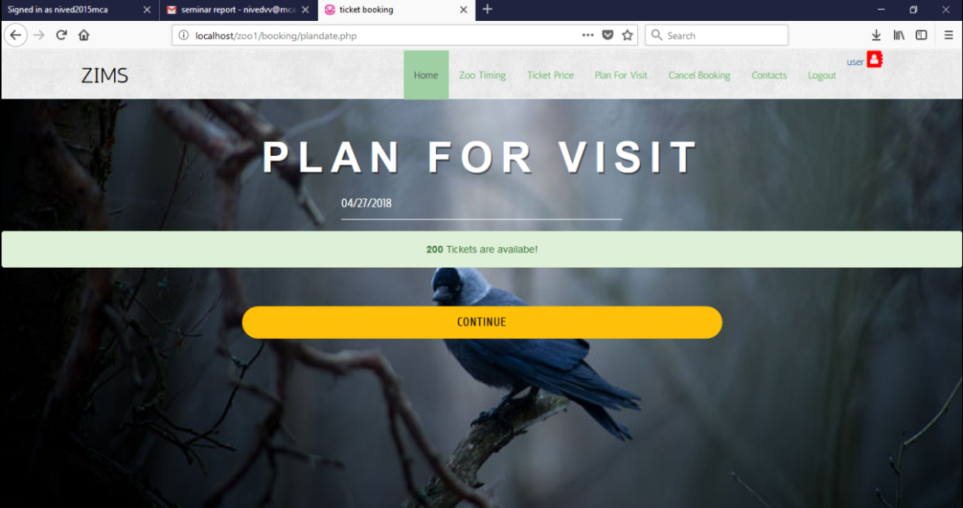

**Figure 23: Booking Page**

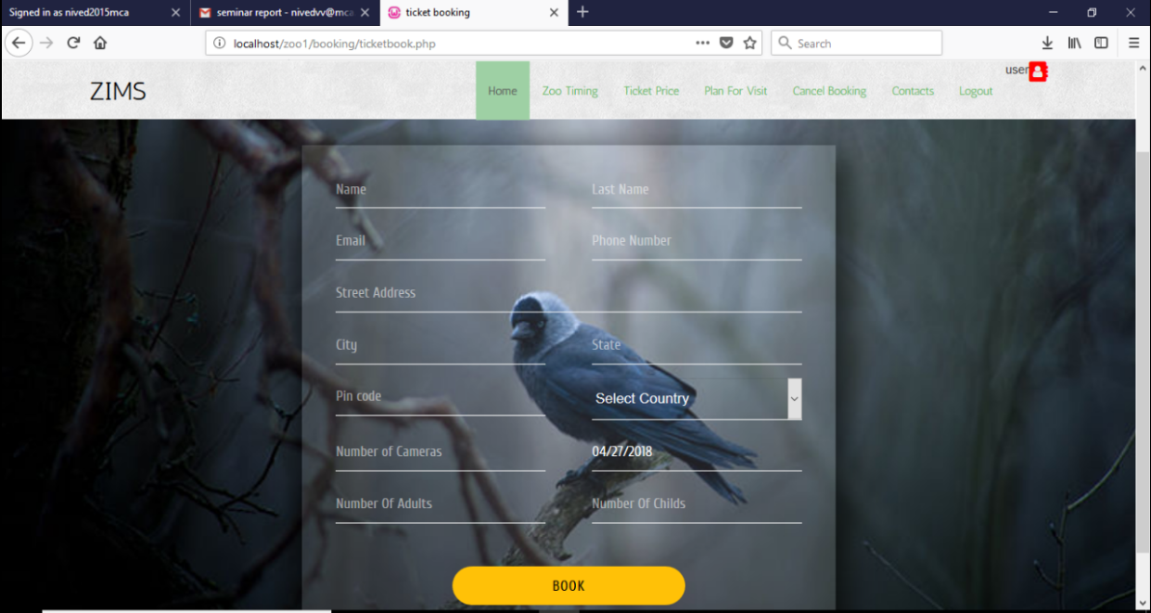

**Figure 24: Payment page**

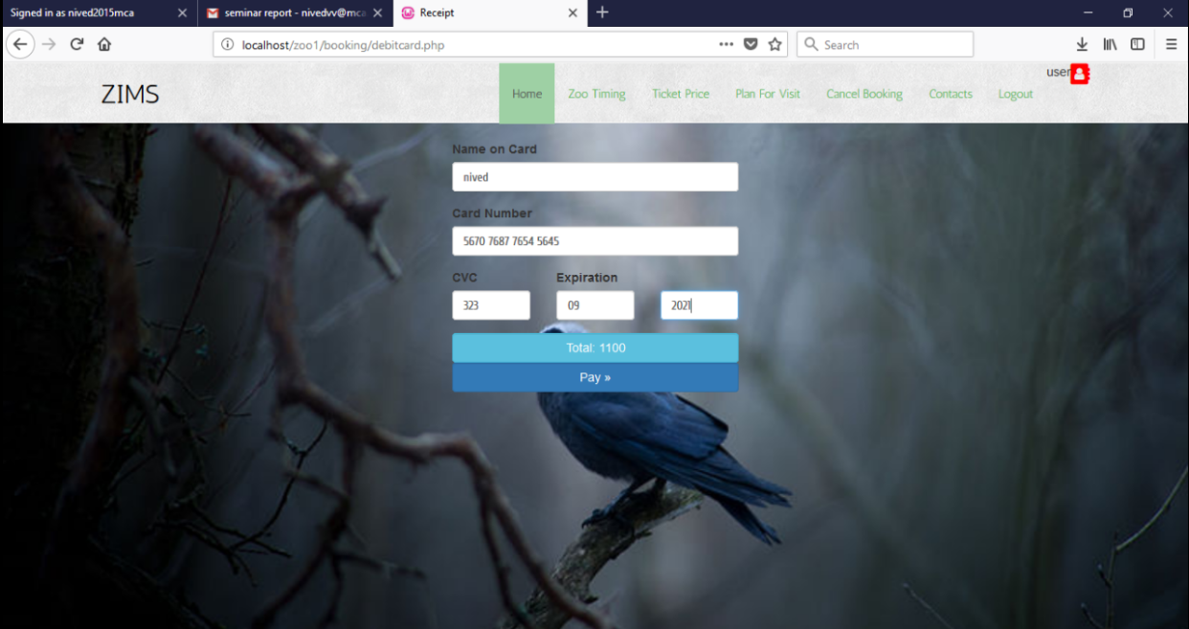

**Figure 25: Receipt**

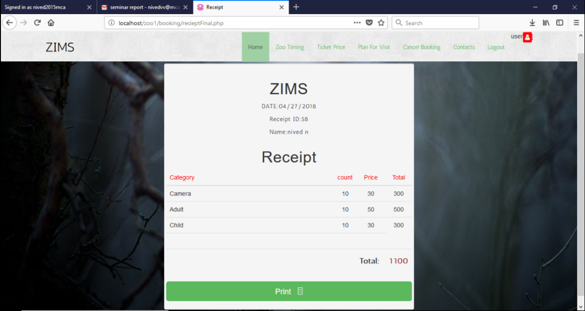

**Figure 26: Ticket cancel**

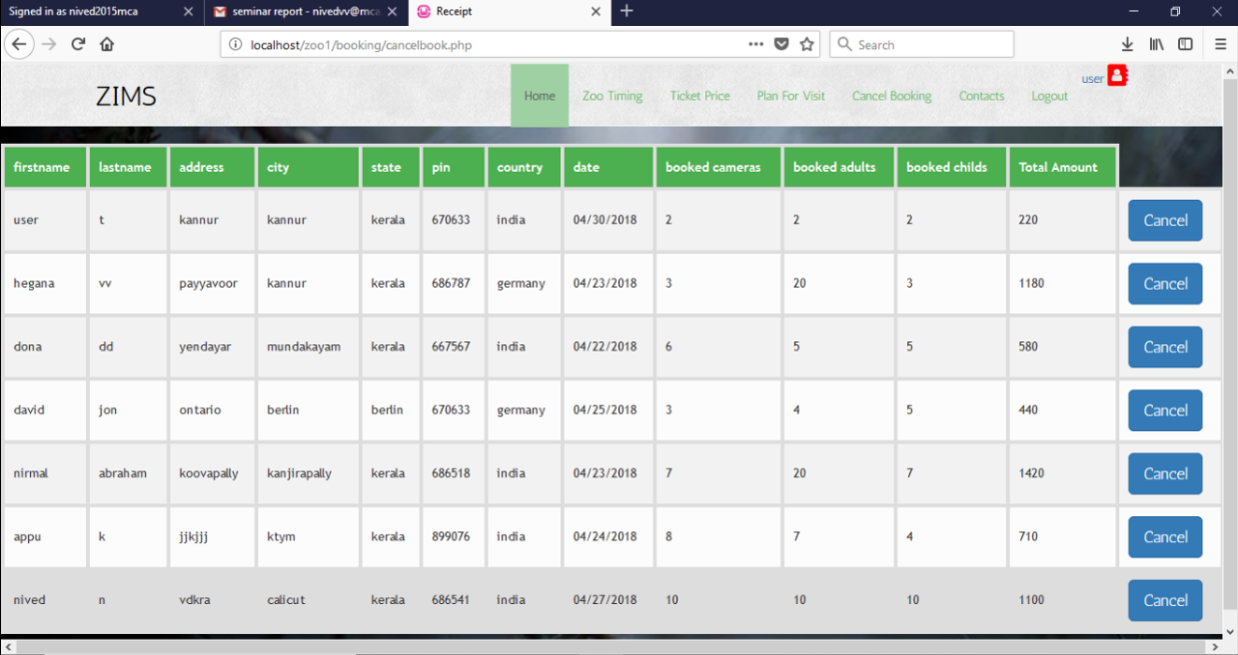

**Figure 27: View ticket price**

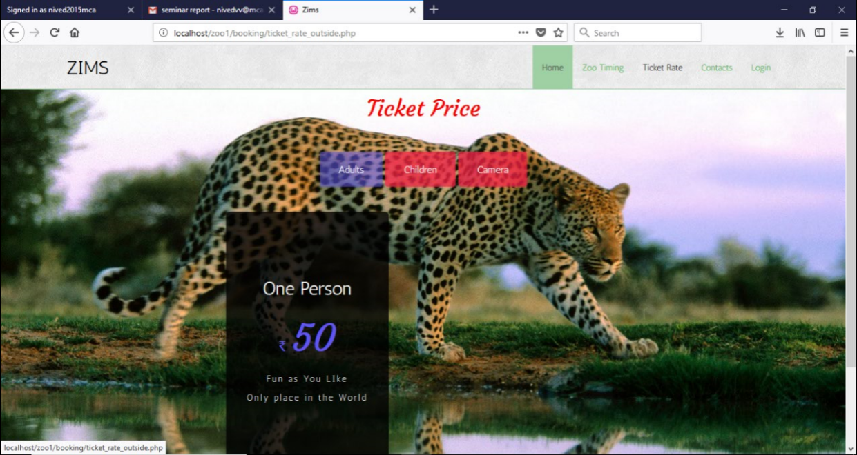

**Figure 28: Edit user profile**

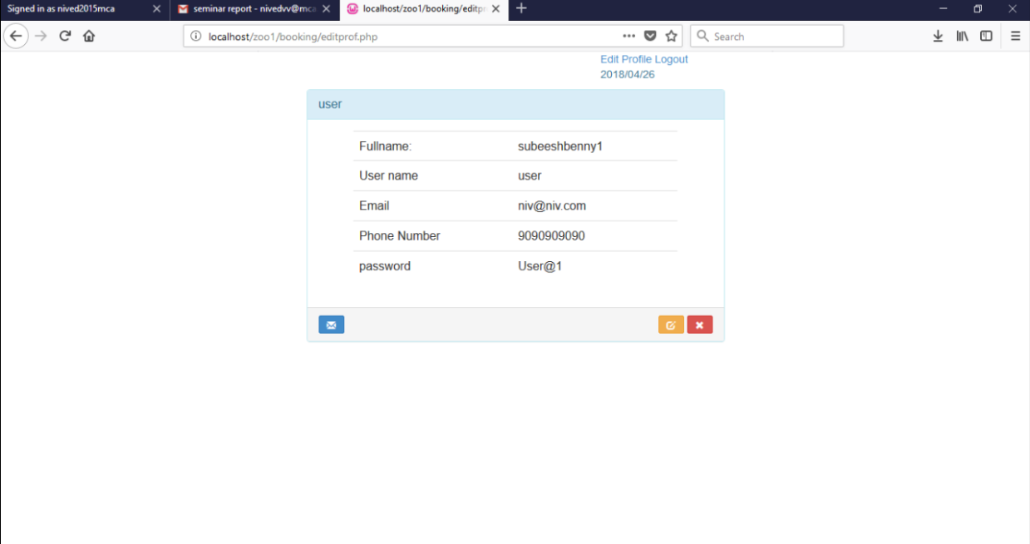

**4.7 DATABASE DESIGN**

A database is an organized mechanism that has the capability of storing information through which a user can retrieve stored information in an effective and efficient manner. The database design is a two-level process. In the first step, user requirements are gathered together and a database is designed which will meet these requirements as clearly as possible. This step is called Information Level Design and it is taken independent of any individual DBMS.

In the second step, this Information level design is transferred into a design for the specific DBMS that will be used to implement the system in question. This step is called Physical Level Design, concerned with the characteristics of the specific DBMS that will be used. A database design runs parallel with the system design. The organization of the data in the database is aimed to achieve the following two major objectives.

* Data Integrity
* Data independence

**4.7.1** **Relational Database Management System (RDBMS)**

A relational model represents the database as a collection of relations. Each relation resembles a table of values or file of records. The rows in a table are called tuples. A tuple is an ordered set of n elements. Columns are referred to as attributes. Relationships have been set between every table in the database. This ensures both Referential and Entity Relationship Integrity. A domain D is a set of atomic values.

**Relationships**

* Table relationships are established using Key. The two main keys of prime importance are Primary Key & Foreign Key. Entity Integrity and Referential Integrity Relationships can be established with these keys.
* Entity Integrity enforces that no Primary Key can have null values.
* Referential Integrity enforces that no Primary Key can have null values.
* Referential Integrity for each distinct Foreign Key value, there must exist a matching Primary Key value in the same domain. Other keys are Super Key and Candidate Keys.

**4.7.2 Normalization**

Normalization is a technique of separating redundant fields and breaking up a large table into a smaller one. It is also used to avoid insertion, deletion, and updating anomalies. Normal form in data modelling use two concepts, keys and relationships. A key uniquely identifies a row in a table. There are two types of keys, primary key and foreign key.

A primary key is an element or a combination of elements in a table whose purpose is to identify records from the same table. A foreign key is a column in a table that uniquely identifies record from a different table. All the tables have been normalized up to the third normal form. Normalization eliminates redundancy and promotes integrity.

**First Normal Form**

The First Normal Form states that the domain of an attribute must include only atomic values and that the value of any attribute in a tuple must be a single value from the domain of that attribute. In other words, 1NF disallows “relations within relations” or “relations as attribute values within tuples”. The only attribute values permitted by 1NF are single atomic or indivisible values. In this, we form new relations for each non-atomic attribute or nested relation.

**Second Normal Form**

According to Second Normal Form, for relations where primary key contains multiple attributes, no non-key attribute should be functionally dependent on a part of the primary key. In this we decompose and setup a new relation for each partial key with its dependent attributes. A relation is said to be in second normal form if and only if it satisfies all the first normal form conditions for the primary key and every non-primary key attribute of the relation is fully dependent on its primary key alone.

**Third Normal Form**

According to Third Normal Form, Relation should not have a non-key attribute functionally determined by another non-key attribute or by a set of non-key attributes. That is, there should be no transitive dependency on the primary key. In this we decompose and set up relation that includes the non-key attributes that functionally determines other non-key attributes. A relation

is said to be in third normal form if only if it is in second normal form and more over the non-key attributes of the relation should not be depend on another non-key attribute.

**TABLE DESIGN**

Database : demo

1. **Table Name: reg**

**Primary Key: regid**

**Foreign key: logid**

|  |  |  |  |
| --- | --- | --- | --- |
| **No** | **Field name** | **Data type** | **Description** |
| 1 | Regid | Integer | Primary key indicating unique user |
| 2 | Logid | Integer | Foreign key |
| 3 | Fname | Varchar(50) | First name of the user |
| 4 | Phone | Varchar(20) | User phone number |
| 5 | Mail | Varchar(30) | User mail id |
| 6 | Status | Integer | Status |

1. **Table Name: booking**

**Primary Key: bid**

|  |  |  |  |
| --- | --- | --- | --- |
| No | Field name | Data type | Description |
| 1 | Bid | Integer | Primary Key |
| 2 | Username | Varchar(50) | User name |
| 3 | Fname | Varchar(50) | First name |
| 4 | Lname | Varchar(50) | Last name |
| 5 | Email | Varchar(50) | Email address |
| 6 | Phone | Varchar(50) | Phone number |
| 7 | Saddress | Varchar(500) | User address |
| 8 | City | Varchar(500) | Living city |
| 9 | State | Varchar(5) | State name |
| 10 | Pin | Integer | Pin number |
| 11 | Country | Varchar(10) | Living country |
| 12 | Camera | Integer | Number of cameras booked |
| 13 | Date | Varchar(10) | Date of visit |
| 14 | Adults | Integer | Number of adults booked |
| 15 | Child | Integer | Number of childrens booked |
| 16 | Total | Integer | Total ticket amount |
| 17 | Status | Integer | Status |

1. **Table Name: loginform**

**Primary Key: ID**

|  |  |  |  |
| --- | --- | --- | --- |
| No | Field name | Data type | Description |
| 1 | ID | Integer | Primary key |
| 2 | User | Varchar(60) | User name |
| 3 | Pass | Varchar(50) | Login password |
| 4 | Role | Int | Login time role check |
| 5 | Status | Int | Status |

**4. Table Name: ticket_dtls**

**Primary Key: tick_id**

|  |  |  |  |
| --- | --- | --- | --- |
| No | Field name | Data type | Description |
| 1 | tick_id | Integer | Primary Key |
| 2 | Category | Varchar(10) | Select category |
| 3 | Price | Integer | Ticket price |
| 4 | Date | Date | Updated date |

**5. Table Name: contact**

|  |  |  |  |
| --- | --- | --- | --- |
| No | Field name | Data type | Description |
| 1 | con_id | Integer | Primary Key |
| 2 | Name | Varchar(50) | Name of user |
| 3 | Email | Varchar(50) | Valid email |
| 4 | Phone | Varchar(50) | Phone number |
| 5 | Message | Varchar(50) | User message |

**Primary Key: con_id**

**6. Table Name: country**

**Primary Key: c_id**

|  |  |  |  |
| --- | --- | --- | --- |
| No | Field name | Data type | Description |
| 1 | c_id | Integer | Primary Key |
| 2 | Country | Varchar(10) | Country name |

**7. Table Name: bookinglimit**

**Primary Key: lid**

|  |  |  |  |
| --- | --- | --- | --- |
| No | Field name | Data type | Description |
| 1 | Lid | Integer | Primary Key |
| 2 | Lim | Varchar(10) | Booking limit |

**SYSTEM TESTING**

**5.1 INTRODUCTION**

Software Testing is the process of executing software in a controlled manner, in order to answer the question - Does the software behave as specified? Software testing is often used in association with the terms verification and validation. Validation is the checking or testing of items, includes software, for conformance and consistency with an associated specification. Software testing is just one kind of verification, which also uses techniques such as reviews, analysis, inspections, and walkthroughs.

Debugging is the process of analyzing and localizing bugs when software does not behave as expected. Debugging is an activity which supports testing, but cannot replace testing.

Other activities which are often associated with software testing are static analysis and dynamic analysis. Static analysis investigates the source code of software, looking for problems and gathering metrics without actually executing the code. Dynamic analysis looks at the behavior of software while it is executing, to provide information such as execution traces, timing profiles, and test coverage information.

Testing is a set of activity that can be planned in advanced and conducted systematically. Testing begins at the module level and work towards the integration of entire computers based system. Nothing is complete without testing, as it vital success of the system testing objectives, there are several rules that can serve as testing objectives.

They are:

* Testing is a process of executing a program with the intent of finding an error.
* A good test case is one that has high possibility of finding an undiscovered error.
* A successful test is one that uncovers an undiscovered error.

There are three ways to test program:

* For correctness
* For implementation efficiency
* For computational complexity

**5.2 TEST PLAN**

A test plan implies a series of desired course of action to be followed in accomplishing various testing methods. The Test Plan acts as a blue print for the action that is to be followed. The specific objectives of testing should be stated in measurable terms. So that the mean time to failure, the cost to find and fix the defects, remaining defect density or frequency of occurrence and test work-hours per regression test all should be stated within the test plan.

The levels of testing include:

* Unit testing
* Integration Testing
* Data validation Testing
* Output Testing

***5.2.1 Unit Testing***

Unit testing focuses verification effort on the smallest unit of software design – the software component or module. Using the component level design description as a guide, important control paths are tested to uncover errors within the boundary of the module.

The unit testing is white-box oriented, and step can be conducted in parallel for multiple components. The modular interface is tested to ensure that information properly flows into and out of the program unit under test. Boundary conditions are tested to ensure that all statements in a module have been executed at least once. Finally, all error handling paths are tested.

Unit testing was done in ‘Zoo Information Management System’ by treating each module as separate entity and testing each one of them with a wide spectrum of test inputs. After coding each module is tested and run individually.

***5.2.2 Integration Testing***

Integration testing is systematic technique for constructing the program structure while at the same time conducting tests to uncover errors associated with interfacing. The objective is to take unit tested components and build a program structure that has been dictated by design. The entire program is tested as whole. Once the errors are corrected, new ones appear and the process continues in a seemingly endless loop. After performing unit testing in the System all the modules were integrated to test for any inconsistencies in the interfaces. Moreover, differences in program structures were removed and a unique program structure was evolved.

***5.2.3 Validation Testing or System Testing***

This is the final step in testing. In this, the entire system was tested as a whole with all forms, code, modules and class modules. This form of testing is popularly known as Black Box testing or System tests.

Black Box testing method focuses on the functional requirements of the software. Black Box testing attempts to find errors in the following categories; incorrect or missing functions, interface errors, errors in data structures or external data access, performance errors and initialization errors and termination errors.

***5.2.4 Output Testing or User Acceptance Testing***

The system considered is tested for user acceptance; here it should satisfy the user’s needs. The software should keep in touch with the user at the time of developing and making changes when required. This done with respect to the following points:

* Input Screen Designs
* Output Screen Designs

The above testing is done taking various kinds of test data. Preparation of test data plays a vital role in the system testing. After preparing the test data, the system under study is tested using that test data. While testing the system by which test data errors are again uncovered and corrected by using above testing steps and corrections are also noted for future use.

**5.3 TEST CASE**

***5.3.1 Test Case 1***

|  |  |  |  |  |  |  |  |
| --- | --- | --- | --- | --- | --- | --- | --- |
| Project Name: Zoo Information Management System | | | | | | | |
| **Zoo Information Management System Test Case 1** | | | | | | | |
| Test Case ID: Test Case 1 | | | | Test Designed by: Subeesh Benny | | | |
| Test Priority(Low/Medium/High): Medium | | | | Test Designed date:20/1/2018 | | | |
| Module Name: Login screen | | | | Test Executed by: Ms. Grace Joseph | | | |
| Test Title: Verify login with valid username and Password | | | | Test Execution date:20/1/2018 | | | |
| Description: Test the Zoo Information Management System Login Page | | | |  | | | |
|  | | | |  | | | |
| Pre-conditions: User has Valid username and Password | | | | | | | |
|  | | | | | | | |
| Step | Test Steps | Test Data | Expected Result | | Actual Result | Status(Pass/Fail) | Note |
| 1 | Navigation to login page |  |  | |  | Fail |  |
| 2 | Provide Valid username | Username: admin | User  should be able to  login | | Logged in and the User is navigated to Dashboard with  Records | Pass |  |
| 3 | Provide valid password | Password: admin |  |
| 4 | Click on login Button |  |  |  |
|  | | | | | | | |
| **Post conditions:**  User is validated with database and successfully login to account. The account session details are logged in database | | | | | | | |

***5.3.2 Test Case 2***

|  |  |  |  |  |  |  |  |
| --- | --- | --- | --- | --- | --- | --- | --- |
| Project Name:Zoo Information Management System | | | | | | | |
| **Zoo Information Management System** **Test Case 2** | | | | | | | |
| Test Case ID: Test Case 2 | | | | Test Designed by: Subeesh Benny | | | |
| Test Priority(Low/Medium/High): High | | | | Test Designed date:24/3/2018 | | | |
| Module Name: Ticket Booking | | | | Test Executed by: Ms. Grace Joseph | | | |
| Test Title: Ticket booking | | | | Test Execution date:24/3/2018 | | | |
| Description: User book the ticket | | | |  | | | |
|  | | | |  | | | |
|  | | | |  | | | |
| Pre-conditions: booking should be available | | | | | | | |
| Dependencies | | | | | | | |
|  | | | | | | | |
| Step | Test Steps | Test Data | Expected Result | | Actual Result | Status(Pass/Fail) | Note |
| 1 | Fill the booking details | booking details | Ticket should be booked | | Message shown | Pass |  |
| 2 | Ticket booking | Booking | If requested ticket is available,ticket is booked | | Message is shown | Pass |  |
|  |  |  |  | |  |  |  |
|  | | | | | | | |
| **Post conditions:**  Data is validated with database and other validations. | | | | | | | |

***5.3.3 Test Cases 3***

|  |  |  |  |  |  |  |  |
| --- | --- | --- | --- | --- | --- | --- | --- |
| Project Name: Zoo Information Management System | | | | | | | |
| **Zoo Information Management System** **Test Case 3** | | | | | | | |
| Test Case ID: Test Case 3 | | | | Test Designed by: Subeesh Benny | | | |
| Test Priority(Low/Medium/High): Medium | | | | Test Designed date:25/4/2018 | | | |
| Module Name: User Registration | | | | Test Executed by: Ms. Grace Joseph | | | |
| Test Title: User Registration | | | | Test Execution date:25/4/2018 | | | |
| Description: Zoo Information Management System user registration | | | |  | | | |
|  | | | |  | | | |
|  | | | |  | | | |
| Pre-conditions: User data should be correct | | | | | | | |
|  | | | | | | | |
| Step | Test Steps | Test Data | Expected Result | | Actual Result | Status(Pass/Fail) | Note |
| 1 | Navigation to  Registration  Page |  |  | |  | Fail |  |
| 2 | Provide  Valid data | Registration Data | Successfully added  message should be shown | | Message own  and redirected to home page | Pass |  |
| 3 | Click on  Save  Button | Validations |  |
|  |  |  |  |  |
|  | | | | | | | |
| **Post conditions:**  Registration data is validated with database and other validations. | | | | | | | |

***5.3.4 Test Case 4***

|  |  |  |  |  |  |  |  |
| --- | --- | --- | --- | --- | --- | --- | --- |
| Project Name: Zoo Information Management System | | | | | | | |
| **Zoo Information Management System** **Test Case 4** | | | | | | | |
| Test Case ID: Test Case 3 | | | | Test Designed by: Subeesh Benny | | | |
| Test Priority(Low/Medium/High): Medium | | | | Test Designed date:25/4/2018 | | | |
| Module Name: Plan For Visit | | | | Test Executed by: Ms. Grace Joseph | | | |
| Test Title:Booking | | | | Test Execution date:25/4/2018 | | | |
| Description: Ticket Booking | | | |  | | | |
| Pre-conditions: Booking data should be correct | | | | | | | |
|  | | | | | | | |
| Step | Test Steps | Test Data | Expected Result | | Actual Result | Status(Pass/Fail) | Note |
| 1 | Navigation to  Booking  Page |  |  | |  | Pass |  |
| 2 | Provide  Valid data | Booking details | Successfully Booked | | Payment Details | Pass |  |
| 3 | Click on  Booking  Button | Validations |  |
|  |  |  |  | |  |  |  |
| **Post conditions:** | | | | | | | |

**5.4 TEST REPORT**

In ‘Zoo Information Management System’, each module is tested and errors are rectified. The testing process is done by providing both valid and invalid data and examined how the system responds under these circumstances.

* **Registration and Login**

In this module, all the fields are validated. The user should enter valid details. If an invalid data is given, then a message is displayed to notify them. In this module, for user registration, the user information like user number, Name, Email are entered into the database.

The user can be registered using username. For user registration, username, and password are given.Then the user can login to the site and can update personal information and password. The ordinary users are directed to their home page.

During the registration process, all the inputs are validated and if there is any error, it is displayed. If a username is already in use, it also displayed. To get in to the system, the users should need a valid username and password.

* **Booking Management**

This module is for handling the booking. The user can book for ticket. The visiting date details are stored into database. The admin can view or search the booking details. The booking details checked by admin with the available date, If book for a date not available, and if user try to book it again, it is not entered into the database.. In all these cases, a success or failure message is given.

* **Payment**

This module is for booking payment for ticket. They can make payment by entering card number, cvv, card expiry date and name on card. During payment, the bank details is validated. The payment is paid through online.

* **User Management**

This module allows to view user details and remove them if needed. The Name, address, contact information etc are given as inputs to the system. Both valid and invalid data are tried and errors are corrected. The admin can view profiles.

**IMPLEMENTATION**

**6.1 IMPLEMENTATION PROCEDURE**

Implementation simply means the process of converting a new revised system design into an operational one. Implementation of software refers to the final installation of the package in its real environment, to the satisfaction of the intended uses and the operation of the system. In the initial stage, people doubt about the software but we have to ensure that:

* The active user must be aware of the benefits of using the new system.
* Their confidence in the software is built up.
* Proper guidance is imparted to the user so that he is comfortable in using the application.

The system can be implemented only after testing is done and if it is found to be working according to the specifications. The more complex the system being implemented, the more involved will be the system analysis and design effort required to implement the three main aspects: education and training, system testing and changeover.

The implementation state involves the following tasks:

* + Careful planning.
  + Investigation of system and constraints.
  + Design of methods to achieve the changeover.
  + Training of the staff in the changeover phase.

***6.1.1 User Training***

User training is designed to prepare the user for testing and converting the system. As system becomes more complex, the need for training is more important. By user training the user comes to know how to enter data, respond to error messages, interrogate the database and call up routine that will produce reports and perform other necessary functions.

After providing the necessary basic training on computer awareness the user will have to be trained on the new application software. This will give the underlying philosophy of the use of the new system such as the screen flow, screen design, type of help on the screen, type of errors while entering the data, the corresponding validation check at each entry and the ways to correct the date entered. This training may be different across different user groups.

***6.1.2 Operational Document***

The ‘Smart Shop’ will provide a user’s manual for the administrator and manager. To assist the user in understanding the product better and to assist them in better utilization of the product and its features, we will be providing an interactive user interface (in DOC format).

***6.1.3******System Maintenance***

Maintenance is the enigma of system development. The maintenance phase of the software cycle is the time in which a software product performs useful work. After a system is successfully implemented, it should be maintained in a proper manner. System maintenance is an important aspect in the software development life cycle. The need for system maintenance is to make the system adaptable to the changes in the environment. Software maintenance is of course, far more than "Finding Mistakes".

**CONCLUSION AND FUTURE ENHANCEMENT**

* 1. **FUTURE ENHANCEMENT**

Mobile is the future of Software Development. With the increase in the number and make of mobile phones, there comes a demand for better applications. An android application can be developed for the ‘Zoo Information Management System’ which allows users to easily access the functionalities of the system.

* 1. **CONCLUSION**

The software reduces the time consumption and the manual efforts of issuing a zoo ticket. It will be a simple platform for users to access services for their huge needs.

The benefits, we can obtain from the new system are:

• Timely and accurate information will be available

• Reduced data loss

• The access time and process time is highly reduced

• Quick data view

• Error free output

The proposed system is expected to replace manual system and provide more efficient performance and services.

**BIBLIOGRAPHY**

**BOOKS/REFERENCES**

* Gary B. Shelly, Harry J. Rosenblatt, “System Analysis and Design”, 2009.
* Roger S Pressman, “Software Engineering”, 1994.
* PankajJalote, “Software engineering: a precise approach”, 2006.
* IEEE Std 1016 Recommended Practice for Software Design Descriptions**.**
* Data Mining: Concepts and Techniques (The Morgan Kaufmann Series in Data Management Systems) by [Jiawei Han](https://www.amazon.in/Jiawei-Han/e/B001H9VJF8/ref=dp_byline_cont_book_1), [Micheline Kamber](https://www.amazon.in/Micheline-Kamber/e/B001K8QN70/ref=dp_byline_cont_book_2), [Jian Pei Professor](https://www.amazon.in/s/ref=dp_byline_sr_book_3?ie=UTF8&field-author=Jian+Pei+Professor&search-alias=stripbooks).
* Data Mining Methods and Techniques – 2009 by [Shawkat Ali](https://www.amazon.in/s/ref=dp_byline_sr_book_1?ie=UTF8&field-author=Shawkat+Ali&search-alias=stripbooks).

**WEBSITES**

* www.w3schools.com
* www.jquery.com
* www.agilemodeling.com/artifacts/useCaseDiagram.htm
* [www.stackoverflow.com](http://www.stackoverflow.com)
* <https://www.slideshare.net>
* http://ieeexplore.ieee.org

**APPENDIX**

**9.1 SAMPLE CODE**

**Ticketbook**

<?php

session_start();

if($_SESSION['user']=='')

{

header('location:../login.php');

}

include 'db_con.php';

if(isset($_POST['submit'])){

$a=$_POST['name'];

$b=$_POST['lname'];

$c=$_POST['phone'];

$d=$_POST['email'];

$e=$_POST['address'];

$f=$_POST['city'];

$g=$_POST['state'];

$h=$_POST['pin'];

$i=$_POST['country'];

$j=$_POST['camera'];

$k=$_POST['date'];

$l=$_POST['adults'];

$m=$_POST['childs'];

$user = $_SESSION['user'];

$sql=" INSERT INTO `booking`(`username`, `fname`, `lname`, `email`, `phone`, `saddress`, `city`, `state`, `pin`, `country`, `camera`, `date`, `adults`, `child`) VALUES ('$user', '$a','$b','$d','$c','$e','$f','$g','$h','$i','$j','$k','$l','$m')";

$result=mysqli_query($con,$sql);

// $sql_s="select max(bid) from booking where email='$d'";

// $res=mysqli_query($con,$sql_s);

// $row1=mysqli_fetch_array($res);

// $_SESSION["bid"]=$row1['max(bid)'];

$_SESSION["bid"]=mysqli_insert_id($con);

// echo $_SESSION["bid"];

header('location:./receipt.php');

// var_dump($result);

// echo $sql;

}

?>

<html>

<head>

<script src="js/reg_validate.js"></script>

<title>ticket booking </title>

<!-- Meta tags -->

<meta name="viewport" content="width=device-width, initial-scale=1" />

<meta http-equiv="Content-Type" content="text/html; charset=utf-8" />

<meta name="keywords" content="Booking Form"/>

<script type="application/x-javascript">

addEventListener("load", function () {

setTimeout(hideURLbar, 0);

}, false);

function hideURLbar() {

window.scrollTo(0, 1);

}

</script>

<!-- Meta tags -->

<!-- Calendar -->

<link rel="stylesheet" href="css/jquery-uical.css" />

<!-- //Calendar -->

<!--stylesheets-->

<link href="css/stylebook.css" rel='stylesheet' type='text/css' media="all">

<!--//style sheet end here-->

<link href="//fonts.googleapis.com/css?family=Cuprum:400,700" rel="stylesheet">

<!-- Bootstrap-CSS --> <link rel="stylesheet" href="css/bootstrap.min.css">

<!-- JQuery --> <script src="js/jquery.min.js"></script>

<!-- Bootstrap-Main --> <script src="js/bootstrap.min.js"> </script>

<link href="css/navbar.css" rel='stylesheet' type='text/css' media="all">

<meta name="viewport" content="width=device-width, initial-scale=1">

<link rel="stylesheet" href="https://cdnjs.cloudflare.com/ajax/libs/font-awesome/4.7.0/css/font-awesome.min.css">

<style>

.navbar {

background-image:url('../img/bg.png');

background-repeat:repeat;

}

</style>

</head>

<body>

<!-- Navigation bar -->

<div class="navbar navbar-default navbar-fixed-top" role="navigation" style="position:sticky">

<div class="container">

<div class="navbar-header">

<button type="button" class="navbar-toggle" data-toggle="collapse" data-target=".navbar-collapse">

<span class="sr-only">Toggle navigation</span>

<span class="icon-bar"></span>

<span class="icon-bar"></span>

<span class="icon-bar"></span>

</button>

<a class="navbar-brand" href="index.html"><span class="green">ZIMS</span></a>

</div>

<nav role="navigation" class="collapse navbar-collapse navbar-right">

<ul class="navbar-nav nav">

<li class="active"><a href="../user.php">Home</a></li>

<li><a href="timing.php">Zoo Timing</a></li>

<li><a href="ticket_price.php">Ticket Price</a></li>

<li><a href="plandate.php">Plan For Visit</a></li>

<li><a href="cancelbook.php">Cancel Booking</a></li>

<li><a href="contact.php">Contacts</a></li>

<li><a href="../login.php">Logout</a></li>

<li><?php echo $_SESSION['user']; ?></li>

<i style="font-size:24px;color:red" class="fa">&#xf2b9;</i>

</ul>

</nav>

</div>

</div><!-- End Navigation bar -->

<h1 class="header-w3ls">

PLAN FOR VISIT</h1>

<div class="appointment-w3">

<form action="" method="post">

<div class="main">

<div class="form-left-w3l">

<input type="text" id="fname" class="top-up" name="name" placeholder="Name" onchange="f()" required="">

</div>

<div class="form-right-w3ls ">

<input type="text" id="fname" class="top-up" name="lname" placeholder="Last Name" onchange="z()" required="">

<div class="clearfix"></div>

</div>

</div>

<div class="main">

<div class="form-left-w3l">

<input type="email" id="mail" name="email" placeholder="Email" onchange="ml()" required="">

</div>

<div class="form-right-w3ls ">

<input class="buttom" type="text" id="phone" name="phone" placeholder="Phone Number" onchange="p()" required="">

<div class="clearfix"></div>

</div>

</div>

<div class="form-add-w3ls">

<input type="text" id="fname" name="address" placeholder="Street Address" onchange="w()" required="">

</div>

<div class="main">

<div class="form-left-w3l">

<input type="text" id="fname" name="city" placeholder="City" onchange="u()" required="">

</div>

<div class="form-right-w3ls ">

<input type="text" id="fname" name="state" placeholder="State" onchange="v()" required="">

<div class="clearfix"></div>

</div>

</div>

<div class="main">

<div class="form-left-w3l">

<input type="text" id="pin" name="pin" placeholder="Pin code" onchange="k()" required="">

</div>

<div class="form-right-w3ls">

<select class="form-control buttom" name="country">

<option value="">

Select Country</option>

<?php

$results=mysqli_query($con,"select * from country");

// $row=mysqli_fetch_row($results);

// echo $row["country"];

// while($row=mysqli_fetch_array($results))

while ( $row=mysqli_fetch_row($results)) {

echo '<option value="'.$row[1].'">'.$row[1].'</option>';

# code...

}

?>

<!-- <option value="category2">Oman</option>

<option value="category1">Australia</option>

<option value="category3">America</option>

<option value="category3">London</option>

<option value="category3">Goa</option>

<option value="category3">Canada</option>

<option value="category3">india</option> -->

</select>

<div class="clearfix"></div>

</div>

</div>

<div class="main">

<div class="form-left-w3l">

<!-- <select class="form-control">

<option value="">Select Half Day/Full Day</option>

<option>Half Day</option>

<option>Full Day</option>

</select> -->

<input type="text" name="camera" id="num_cam" placeholder="Number of Cameras" onchange="no_cam()" min=0 oninput="validity.valid||(value='');" required="">

</div>

<div class="form-right-w3ls">

<input readonly id="datepicker1" name="date" type="text" placeholder="Date of plan" value="<?php if(isset($_POST["dateXz"])){ echo $_POST["dateXz"]; } ?>">

<div class="clearfix"></div>

</div>

</div>

<div class="main">

<div class="form-left-w3l ">

<input type="text" name="adults" id="num_adu" placeholder="Number Of Adults" onchange="no_adu()" required="">

</div>

<div class="form-right-w3ls">

<input type="text" name="childs" id="num_chi" placeholder="Number Of Childs" onchange="no_chi()" required=""><br>

<!-- <input type="submit" name="submit" value="BOOK"> -->

<div class="clearfix"></div>

</div>

</div>

<!-- <div class="form-add-w3ls">

<input type="text" name="camera" placeholder="Number of Cameras" required="">

</div> -->

<!-- <div class="main"> -->

<center>

<input type="submit" name="submit" value="BOOK">

</center>

<!-- </div> -->

</form>

</div>

<!-- js -->

<script type='text/javascript' src='js/jquery-2.2.3.min.js'></script>

<!-- //js -->

<!-- Calendar -->

<script src="js/jquery-uibook.js"></script>

<script>

$(function () {

$date = $("#datepicker1").val();

$("#datepicker,#datepicker1,#datepicker2,#datepicker3").datepicker({

minDate:$date,

maxDate:$date

});

});

</script>

<!-- //Calendar -->

</body>

</html>